Linear Regression Theory
What is Linear Regression?
Linear Regression is a supervised machine learning algorithm used to predict a continuous numerical target variable by establishing a linear relationship between one or more independent variables (features) and a dependent variable (target).
The objective of Linear Regression is to find the best-fitting straight line that minimizes the prediction error.
Examples:
- Predicting house prices
- Predicting employee salaries
- Predicting sales revenue
- Predicting temperature
- Predicting demand

Simple Linear Regression
Simple Linear Regression uses one independent variable.
The mathematical equation is
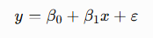
Where
- y = Dependent variable (Target)
- x = Independent variable (Feature)
- β₀ = Intercept
- β₁ = Slope (Coefficient)
- ε = Error (Residual)
Example
Suppose
- House Area = 1500 sq.ft
- Intercept = 20
- Slope = 0.25
Then
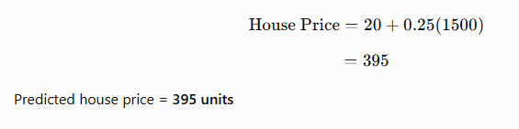

Multiple Linear Regression
When multiple features influence the target, Multiple Linear Regression is used.
The equation becomes
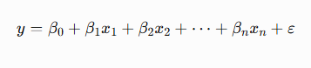
Example
House Price depends on
- Area
- Number of Bedrooms
- Age
- Distance to City
- Income

Components of Linear Regression
Component | Description
x | Independent Variable
y | Dependent Variable
β₀ | Intercept
β₁ | Coefficient
ε | Error Term

What is the Intercept?
The intercept is the predicted value of y when all feature values are zero.
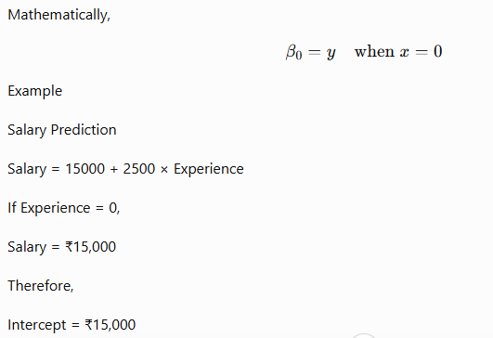
What is the Slope (Coefficient)?
The slope indicates how much the target changes when the feature increases by one unit.
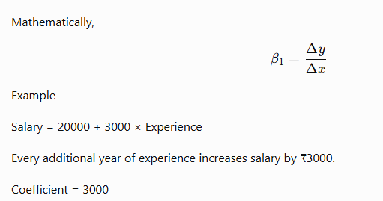
Best Fit Line
Linear Regression tries to identify the straight line that best represents the relationship between the data points.
A good regression line
- passes close to most observations
- minimizes prediction errors
- captures the overall trend
The line is called the Best Fit Line.

Prediction
After training,
The model predicts
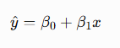Notice
- y → Actual Value
- ŷ → Predicted Value

Residual (Error)
Residual is the difference between the actual value and predicted value.
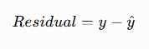Example
Actual Price = ₹50 Lakhs
Predicted Price = ₹47 Lakhs
Residual = ₹3 Lakhs
A good model should have small residuals.

Why Can't We Draw Any Random Line?
Consider these points
Area | Price
1000 | 200
1200 | 250
1400 | 300
1600 | 350
Many straight lines can pass through these points.
The question is
Which line is the best?
The answer is
The line that minimizes the prediction errors.

Least Squares Method
Linear Regression uses the Ordinary Least Squares (OLS) method.
Instead of minimizing errors directly,
it minimizes the sum of squared residuals.
Mathematically,
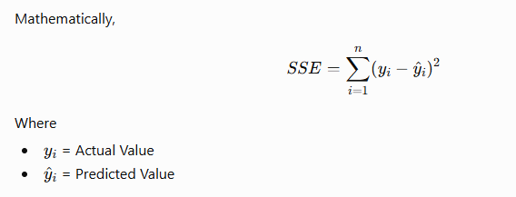

Why Square the Errors?
Suppose
Errors are
- +5
- -5
If added directly,
5 + (-5) = 0
This incorrectly suggests there is no error.
Squaring gives
25 + 25 = 50
Therefore,
- Negative errors become positive.
- Larger errors receive greater penalties.
- The objective function becomes differentiable.

How are Coefficients Calculated?
There are two popular approaches.
1. Ordinary Least Squares (OLS)
Computes coefficients directly using matrix algebra.
Used in scikit-learn's LinearRegression.
Advantages
- Fast
- Exact solution
- Preferred for small and medium datasets

2. Gradient Descent
Starts with random coefficients.
Repeatedly updates them until the cost function becomes minimum.
Used mainly in
- Neural Networks
- Deep Learning
- Very large datasets
Update equations
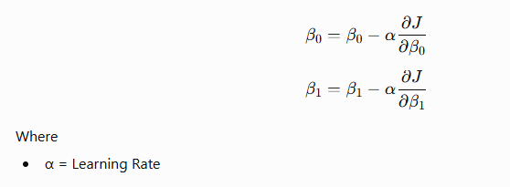
Assumptions of Linear Regression
A Linear Regression model performs well only when these assumptions are reasonably satisfied.
1. Linearity
There should be a linear relationship between the independent variables and the target.
If the relationship is curved, Linear Regression may not perform well.

2. Independence of Errors
Residuals should be independent of one another.
One prediction error should not influence another.
This assumption is especially important in time-series data.

3. Homoscedasticity
The variance of residuals should remain constant across all predicted values.
Good Model
. . . . .
. . . . . .
. . . . .
Bad Model (Heteroscedasticity)
.
.
.
..
....
.......
Increasing spread indicates violation of the assumption.

4. Normality of Residuals
Residuals should approximately follow a normal distribution.
This assumption is particularly important for statistical inference, confidence intervals, and hypothesis testing.

5. No Multicollinearity
Independent variables should not be highly correlated with each other.
Example
Area (sq.ft)
Area (sq.m)
These two variables contain almost identical information, causing unstable coefficient estimates.
Variance Inflation Factor (VIF) is commonly used to detect multicollinearity.

6. No Significant Outliers
Extreme values can disproportionately influence the regression line, leading to biased coefficients and poor predictions.
Outliers should be identified and treated before model training.

Advantages of Linear Regression
- Easy to understand and implement
- Fast training and prediction
- Highly interpretable coefficients
- Computationally efficient
- Works well for linear relationships
- Provides a strong baseline model

Limitations of Linear Regression
- Assumes linear relationships
- Sensitive to outliers
- Affected by multicollinearity
- Can underfit complex data
- Performance decreases when assumptions are violated
This theoretical section provides the mathematical background students need before moving into model building, training, and evaluation.

This is a good OLS summary. Below is a student-friendly interpretation that you can paste into your notebook after the summary() output.

Interpretation of OLS Summary
1. R-squared (R²)
R-squared = 0.613
Interpretation
- R² measures how well the model explains the variation in the target variable.
- Here,
61.3% of the variation in house prices is explained by the selected features.
The remaining 38.7% is due to factors not included in the model or random variation.
Rule of Thumb
R² | Interpretation
< 0.50 | Weak model
0.50 – 0.70 | Moderate model
0.70 – 0.90 | Good model
> 0.90 | Excellent fit (not always desirable due to possible overfitting)
Inference
The model has moderate predictive power.

2. Adjusted R²
Adjusted R² = 0.612
Interpretation
Adjusted R² penalizes unnecessary features.
Since
R² = 0.613
Adjusted R² = 0.612
the difference is very small.
Inference
Almost every feature contributes useful information.
No evidence of unnecessary variables.

3. F-statistic
F-statistic = 3261
Prob(F-statistic)=0.000
Interpretation
The F-test checks
"Is the overall regression model significant?"
Since
p-value = 0.000
which is less than 0.05,
we reject the null hypothesis.
Inference
The model as a whole is statistically significant.
At least one independent variable has a significant relationship with the target.

4. Intercept (Constant)
const = -37.0233
Interpretation
When every feature is zero,
the predicted house value becomes
-37.02
Practically this has no real-world meaning, because all features cannot realistically be zero.
It mainly helps position the regression plane.

5. Coefficients
Each coefficient tells how much the target changes when the feature increases by one unit, while keeping all other variables constant.

MedInc
Coefficient = 0.4487
Inference
If Median Income increases by 1 unit,
house value increases by approximately 0.45 units.
Positive relationship.
Highly significant.

HouseAge
0.0097
Older houses slightly increase predicted value.
Very small positive effect.

AveRooms
-0.1233
Negative coefficient.
When average rooms increase by one unit,
predicted house value decreases.
This may appear surprising, but it can occur because other correlated variables (like income and occupancy) are already included in the model.

AveBedrms
0.7831
Strong positive coefficient.
Higher average bedrooms are associated with higher house values.

Population
-2.03e-06
Almost zero.
Population has almost no influence on prediction.

AveOccup
-0.0035
Negative relationship.
Higher occupancy slightly reduces house value.

Latitude
-0.4198
Negative relationship.
Location affects house value significantly.

Longitude
-0.4337
Negative relationship.
Geographic location strongly influences house prices.

6. P-value
A feature is considered statistically significant when
P-value < 0.05
Feature | P-value | Significant?
MedInc | 0.000 | Yes
HouseAge | 0.000 | Yes
AveRooms | 0.000 | Yes
AveBedrms | 0.000 | Yes
Population | 0.699 | No
AveOccup | 0.000 | Yes
Latitude | 0.000 | Yes
Longitude | 0.000 | Yes
Inference
Only Population is not statistically significant because
0.699 > 0.05
It contributes very little to predicting house prices.
In practice, this feature could be considered for removal during feature selection.

7. Confidence Interval
Example
MedInc

0.439 to 0.458
Interpretation
We are 95% confident that the true coefficient lies within this interval.
Since the interval does not include zero,
the feature is statistically significant.

8. Durbin-Watson
1.962
Measures autocorrelation of residuals.
Ideal value
≈ 2
Inference
Residuals are approximately independent.
No serious autocorrelation problem.

9. Omnibus Test
Prob = 0.000
Tests whether residuals are normally distributed.
Since
0.000 < 0.05
Residuals are not perfectly normal.
This is common in large real-world datasets.

10. Jarque-Bera Test
9371.466

P-value = 0.000
Another normality test.
Inference
Residuals deviate from a perfect normal distribution.

11. Skewness
1.071
Positive skew.
Residuals are slightly skewed to the right.

12. Kurtosis
6.006
A normal distribution has a kurtosis of about 3.
Since 6.006 > 3, the residuals have heavier tails than a normal distribution, indicating more extreme values (outliers) than expected.

13. Condition Number
2.38 × 10⁵
This value should ideally be small.
A very large condition number suggests:
- Multicollinearity (features are highly correlated)
- Numerical instability
Inference
The dataset may contain correlated features. This doesn't necessarily make the model unusable, but it's a signal to investigate multicollinearity using techniques like the Variance Inflation Factor (VIF) or correlation analysis.

Overall Conclusion
- The overall regression model is statistically significant.
The model explains about 61.3% of the variation in house prices.
- Most predictors are statistically significant.
- Population is not a significant predictor.
- Residuals show little autocorrelation (Durbin–Watson ≈ 2).
- Residuals are not perfectly normal, which is common with large datasets.
- The high condition number suggests possible multicollinearity, so further diagnostics such as VIF are recommended.
- Overall, the model is suitable as a baseline Linear Regression model, with room for improvement through feature engineering, feature selection, or more advanced regression techniques.

How is R² Calculated?
R² measures how much of the variation in the target variable is explained by the model.
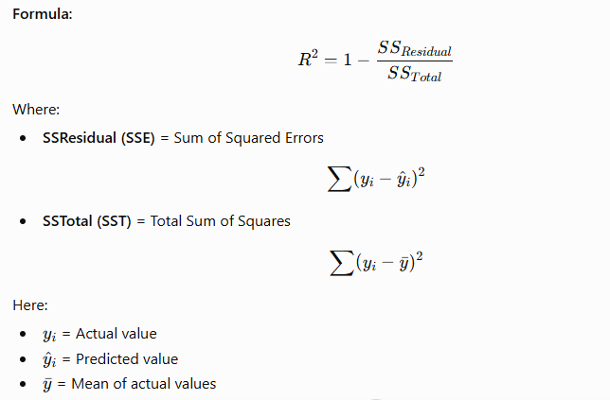Interpretation:
- R² = 0 → Model explains none of the variation.
- R² = 1 → Model explains all the variation.

How is Adjusted R² Calculated?
Adjusted R² penalizes the addition of unnecessary features.
Formula:
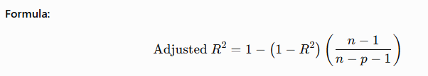Where:
- n = Number of observations (rows)
- p = Number of independent variables (features)
- R² = Coefficient of determination
Interpretation:
- If a new feature improves the model, Adjusted R² increases.
- If a new feature is irrelevant, Adjusted R² decreases or remains almost unchanged.

For Your Model
- R² = 0.613 → The model explains 61.3% of the variation in house prices.
- Adjusted R² = 0.612 → After accounting for the 8 features, the explanatory power is 61.2%.
Since the difference (0.001) is very small, it indicates that almost all selected features contribute meaningfully to the model, with little evidence of unnecessary predictors.

